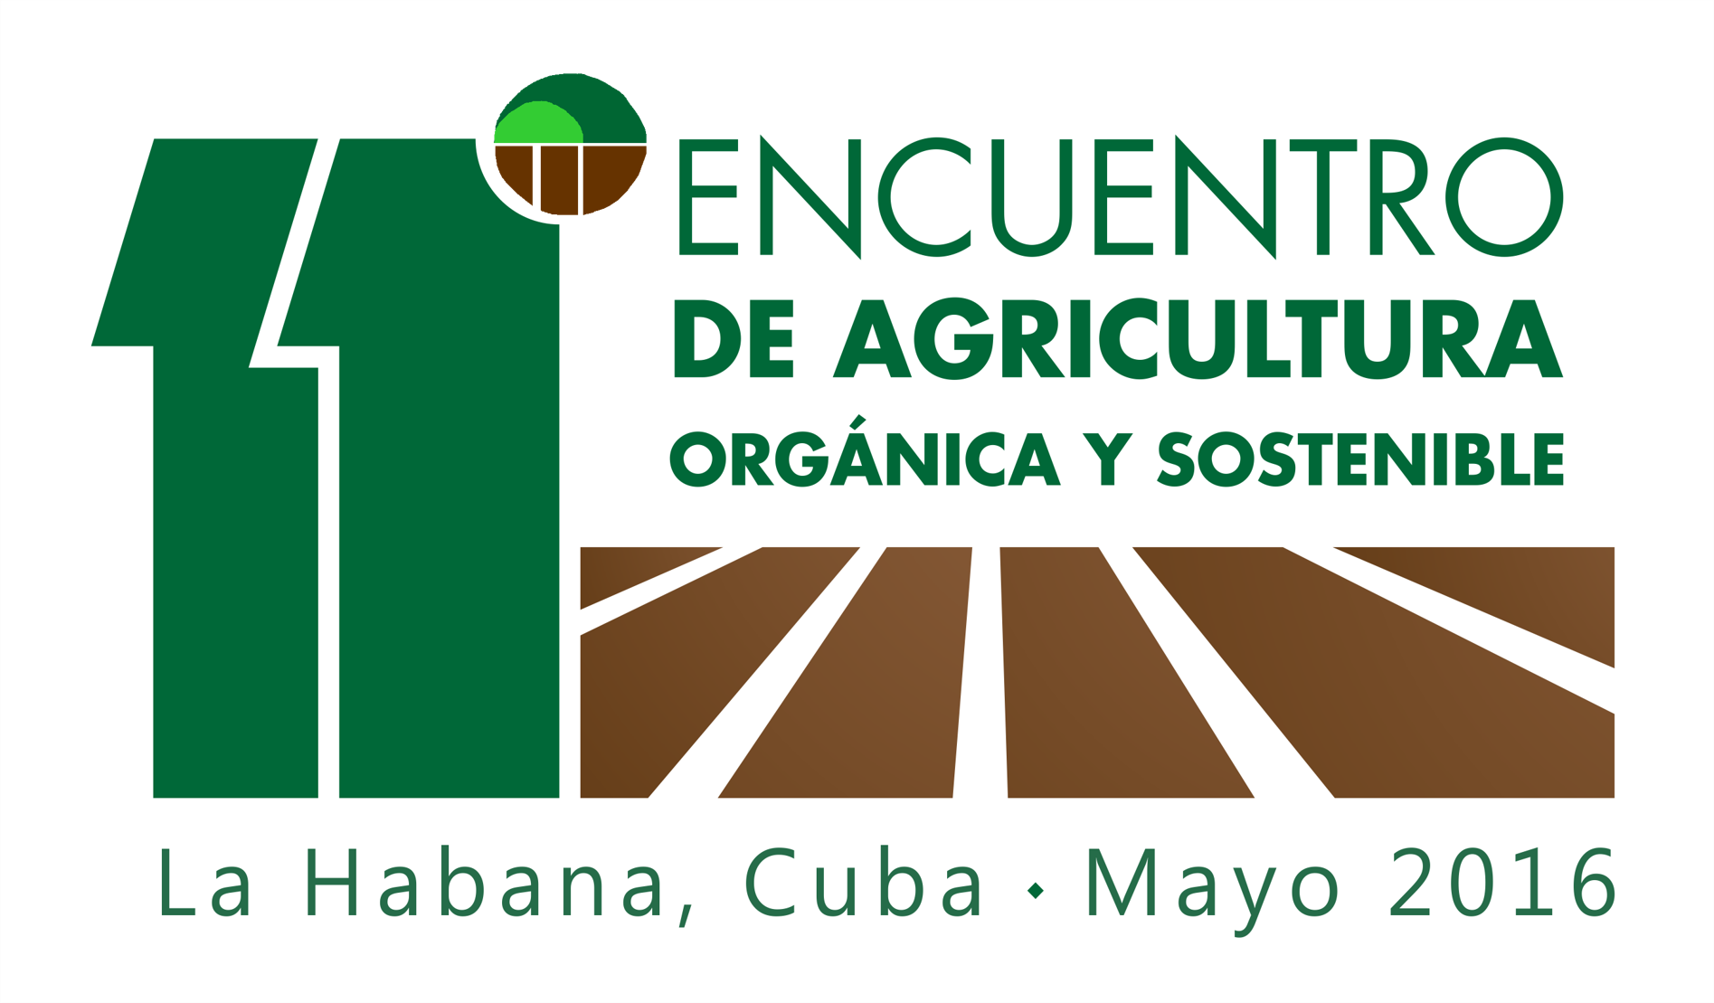

XI INTERNATIONAL MEETING ON ORGANIC AND SUSTAINABLE AGRICULTURE
REGISTRATION FORM
Names and surnames: ___________________________________________________________
Nationality: ______________________________ Passport No.____________________
Country of residence: __________________ Institution: _____________________________
Will participate in (mark with an X):
Course Pre Event ______
Main Event _____ as Contributor ____ Participant_______
Post event tour_____
Presentation title: ____________________________________________________________
Email: _______________________________
Observations:

